phonebook app

User Documentation

Table of Contents

WELCOME PAGE 2

Make a call 2

Send an SMS 4

Camera 5

Call API 7

Set Dark/Light Theme 8

LIST PAGE 10

Add a Contact 10

Edit a Contact 13

Delete a Contact 16

Search a Contact 18

Sort Contacts order 20

WELCOME PAGE

## Make a call

* To make a call, simply just click on the "CALL" button to navigate to "Call Page".

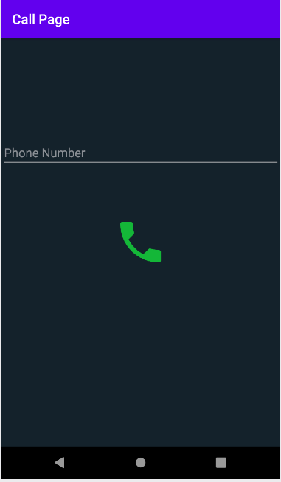

* Insert the number you want to call and then tap on the Phone icon to start a call.

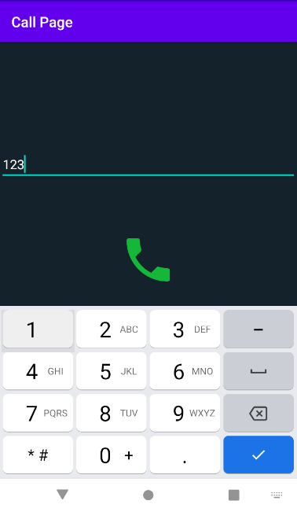

## Send an SMS

* To send an SMS, simply just click on the "SMS" button to navigate to "SMS Page”.

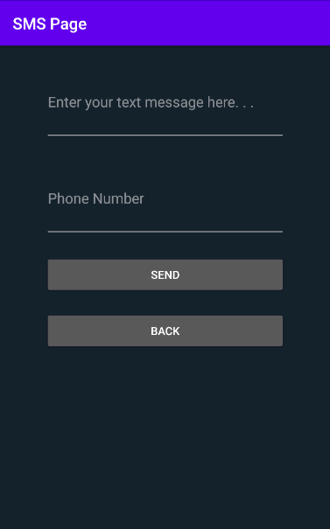

* Enter the text message and the phone number in the corresponding text fields, then just click on "SEND" button to send it through. Click on “BACK” button to go back to the main page.

## Camera

* To take a photo, just simply click on the "CAMERA" button to navigate to "Camera Page".

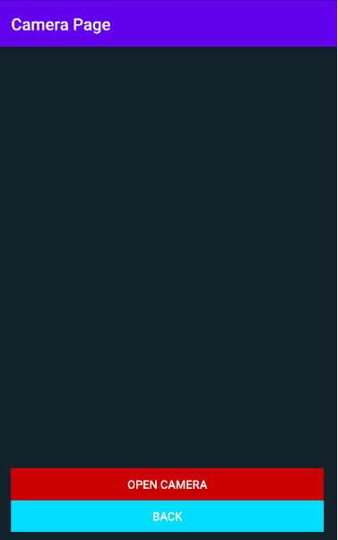

* Click on "OPEN CAMERA" button to open the camera. Now, just click on the photo icon to shoot a photo. Once taken you can choose if save it or not. Click on “BACK” button to go back to the main page.

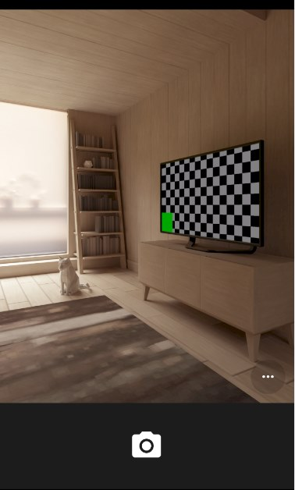

## Call API

* Click on the “Call API” button to send a Contact to the server-side database. A confirmation message will pop up when the action will successfully performed.

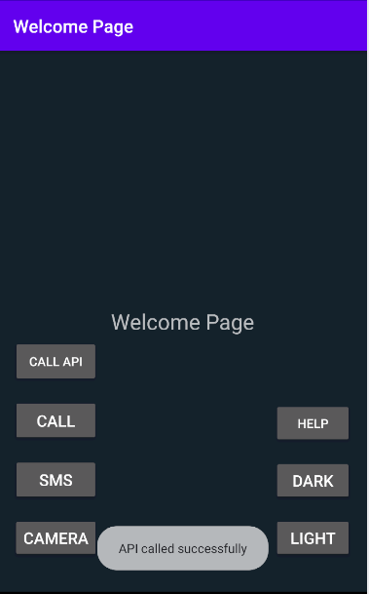

## Set Dark/Light Theme

* Click on "DARK" button to switch the app into a dark color theme.

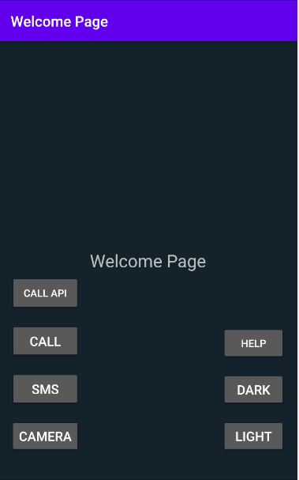

* Click on "LIGHT" button to switch the app into a light color theme.

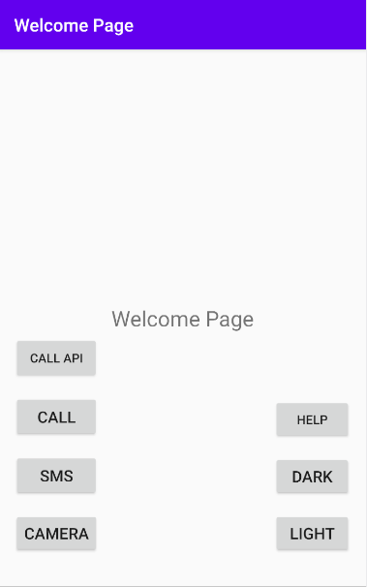

LIST PAGE

## Add a Contact

* Swipe left on "Welcome Page" to be redirected to "List Page".

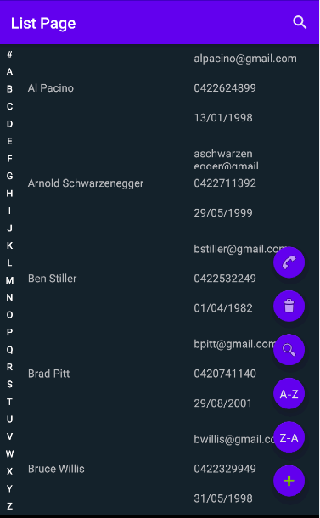

* Click on the "+" icon to navigate to "Add Page".

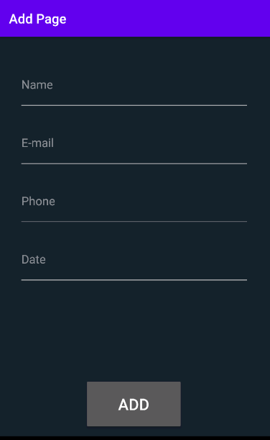

* Fill all the contact details boxes up, then just simply tap the "ADD" button to save the contact.

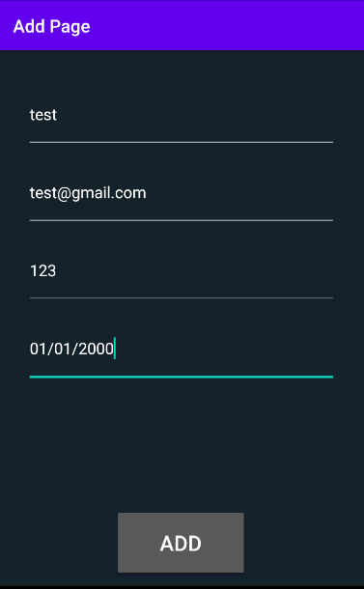

## Edit a Contact

* Swipe left on "Welcome Page" to be redirected to "List Page".



* Swipe left on a Contact. An update icon will pop up.



* Click on the update icon to navigate to "Edit Page”.

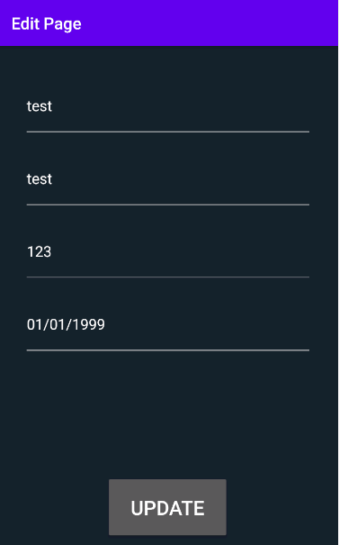

* Edit the contact details desired, then click on the "UPDATE" button to save.

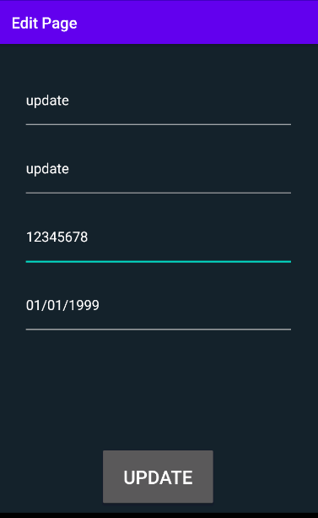

## Delete a Contact

* Swipe left on "Welcome Page" to be redirected to "List Page".



* Click and hold on a contact for 2 seconds and drag it to the bin icon. A message will pop up saying: "Do you wish to delete?" Click on “YES” to successfully delete the contact selected.

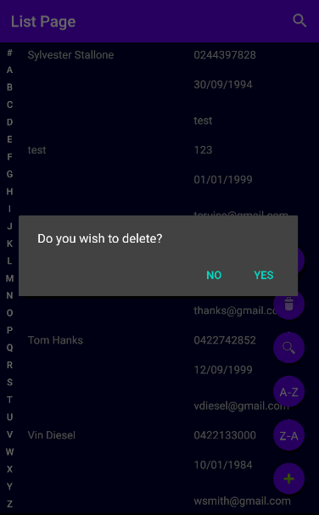

## Search a Contact

* Swipe left on "Welcome Page" to be redirected to "List Page".



* Tap the search icon then tap again to write the Contact you are looking for.

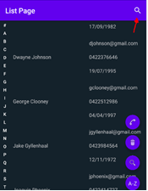

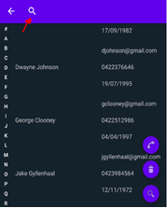

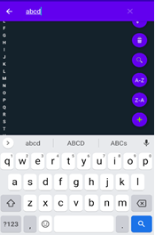

## Sort Contacts order

* Swipe left on "Welcome Page" to be redirected to "List Page".



* Click on the "Z-A" icon to reverse the order of the contact list. Click on the "A-Z" icon to order the contact list back again.